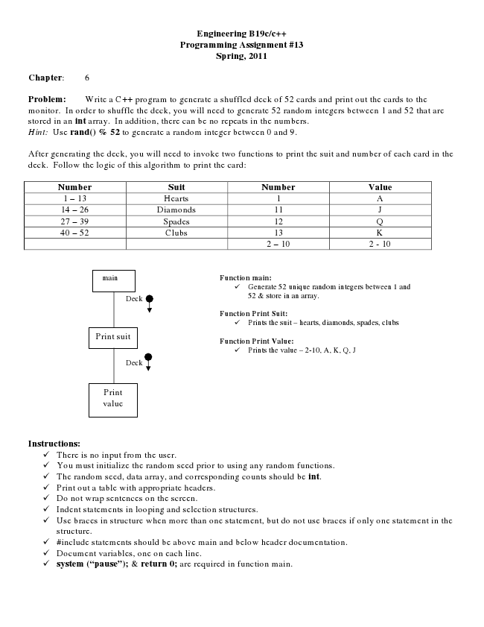

**Engineering B19c/c++ Programming Assignment #13 Spring, 2011**

**Chapter: 6**

Problem: Write a C++ program to generate a shuffled deck of 52 cards and print out the cards to the monitor. In order to shuffle the deck, you will need to generate 52 random integers between 1 and 52 that are stored in an int array. In addition, there can be no repeats in the numbers. Hint: Use rand() % 52 to generate a random integer between 0 and 9.

After generating the deck, you will need to invoke two functions to print the suit and number of each card in the deck. Follow the logic of this algorithm to print the card:

Number Suit Number Value 1 – 13 Hearts 1 A 14 – 26 Diamonds 11 J 27 – 39 Spades 12 Q 40 – 52 Clubs 13 K

2 – 10 2 - 10

main

**Function main:**

✓ Generate 52 unique random integers between 1 and Deck

52 & store in an array.

**Function Print Suit:**

✓ Prints the suit – hearts, diamonds, spades, clubs Print suit

**Function Print Value:**

Deck

**Instructions:**

✓ There is no input from the user. ✓ You must initialize the random seed prior to using any random functions. ✓ The random seed, data array, and corresponding counts should be int. ✓ Print out a table with appropriate headers. ✓ Do not wrap sentences on the screen. ✓ Indent statements in looping and selection structures. ✓ Use braces in structure when more than one statement, but do not use braces if only one statement in the

structure. ✓ #include statements should be above main and below header documentation. ✓ Document variables, one on each line. ✓ system (“pause”); & return 0; are required in function main.

✓ Prints the value N

– 2-10, A, K, Q, J

Print value